**Student Name:** [malak ahmed]  
**Project Title:** Online competition Platform

**Introduction**:

I built this website using HTML, CSS, and PHP. It is a competition website, each competition is about a specific subject, such as math, programming, entrepreneurship, and general information. Using PHP, I was able to record the score in the database and display the results to the user in the form of a dashboard.

**The framework:**

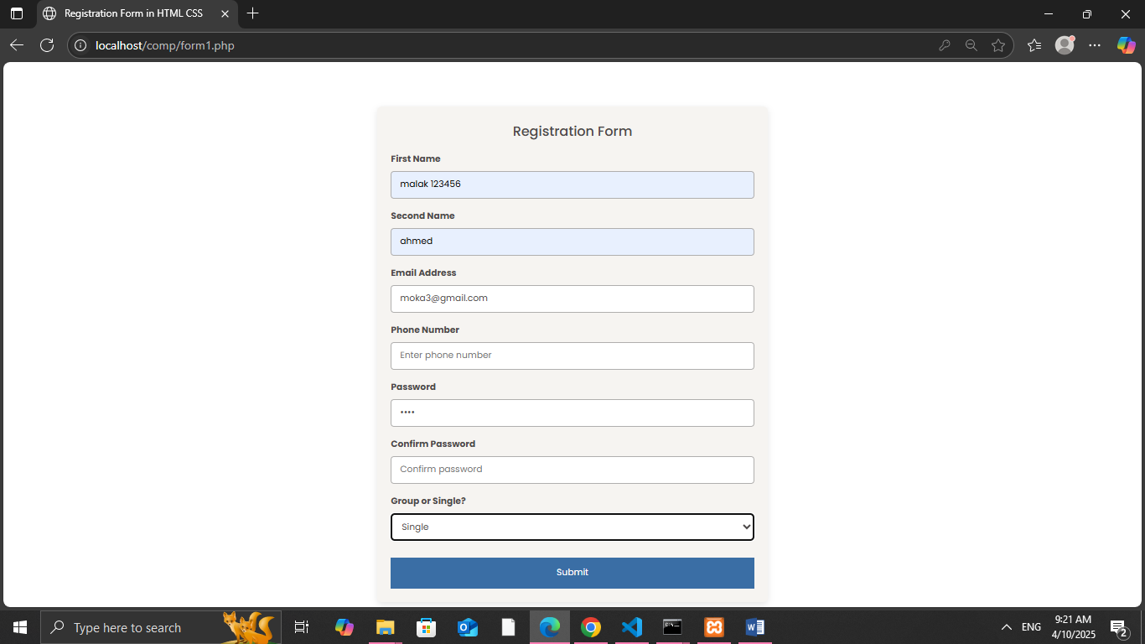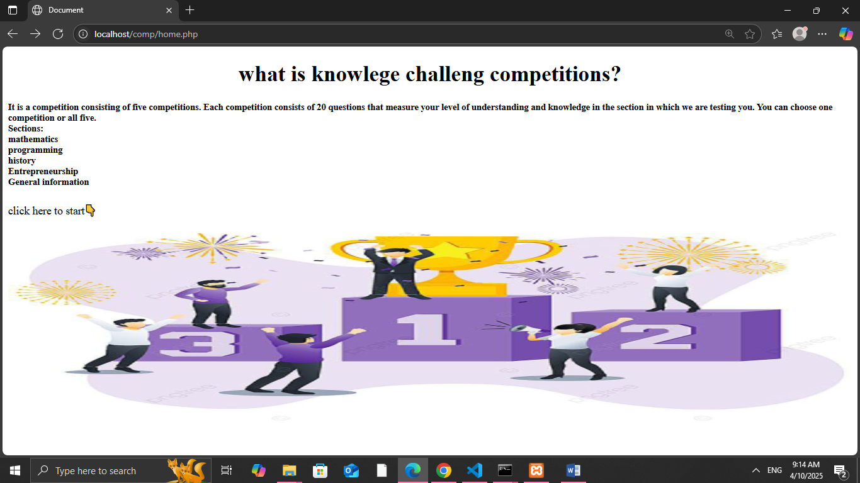

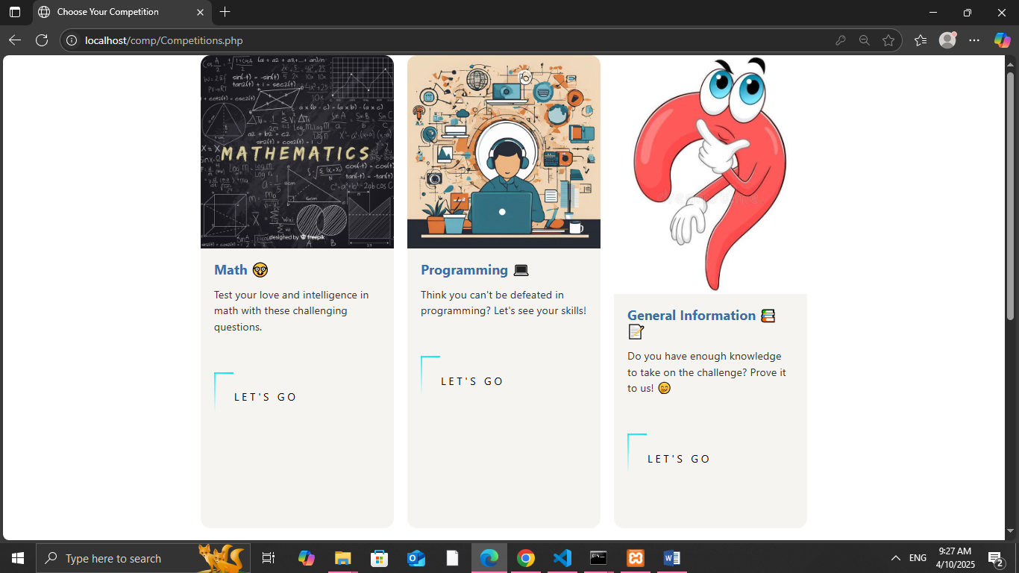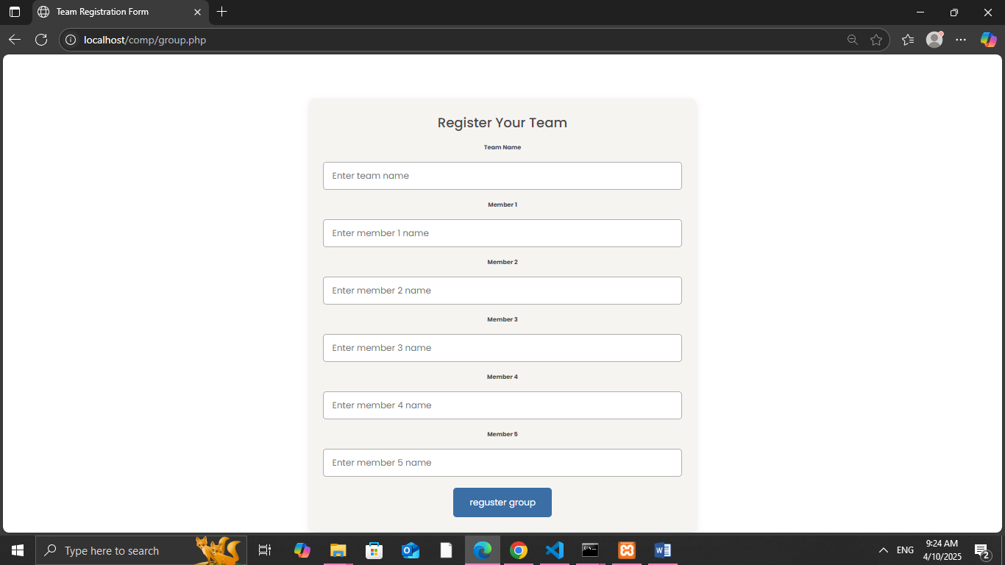

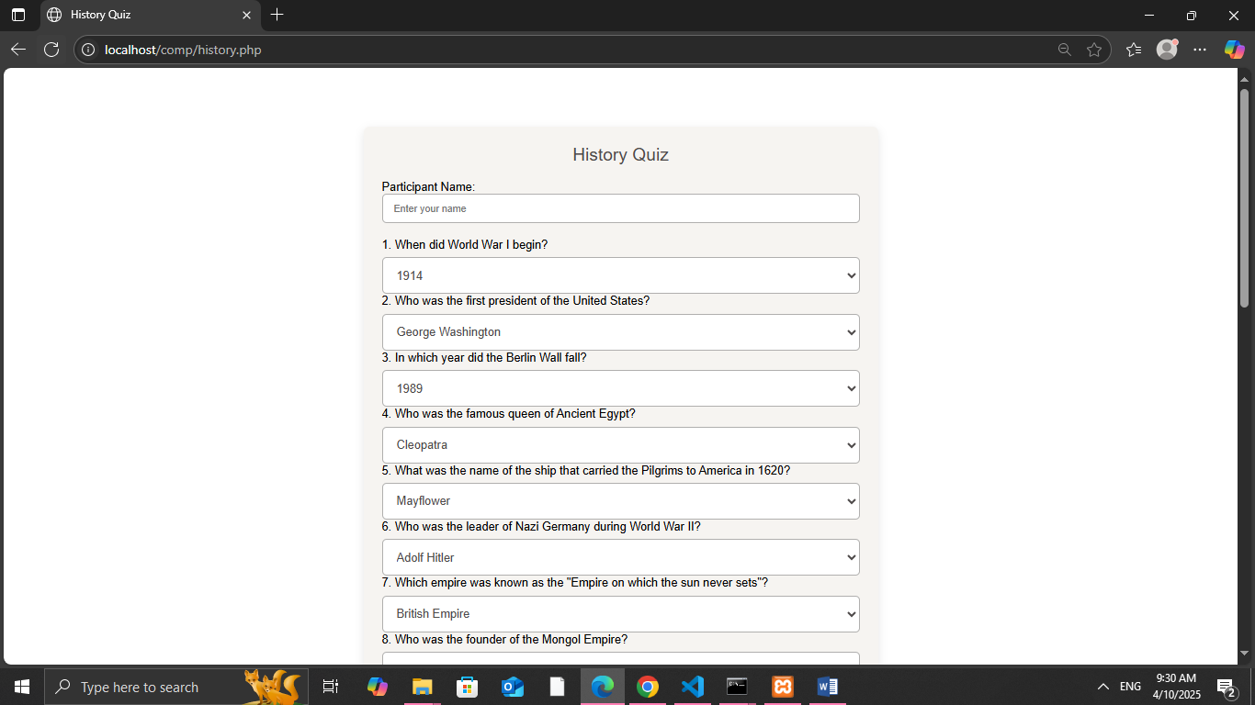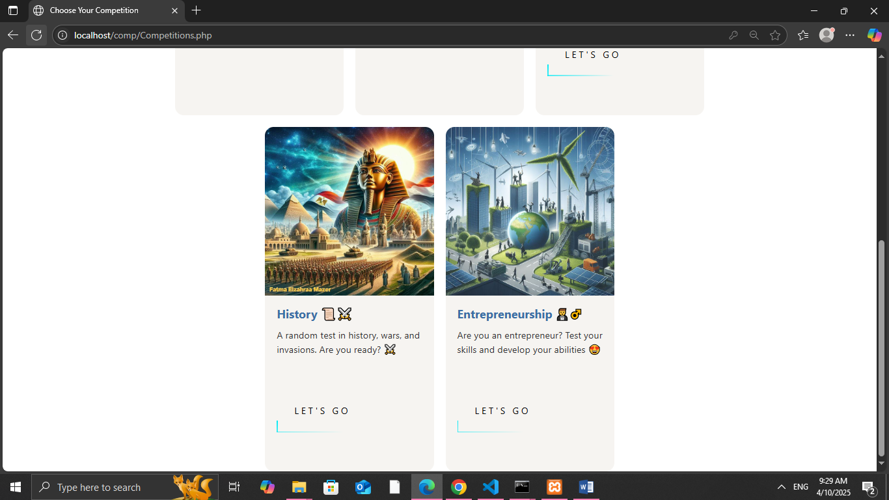

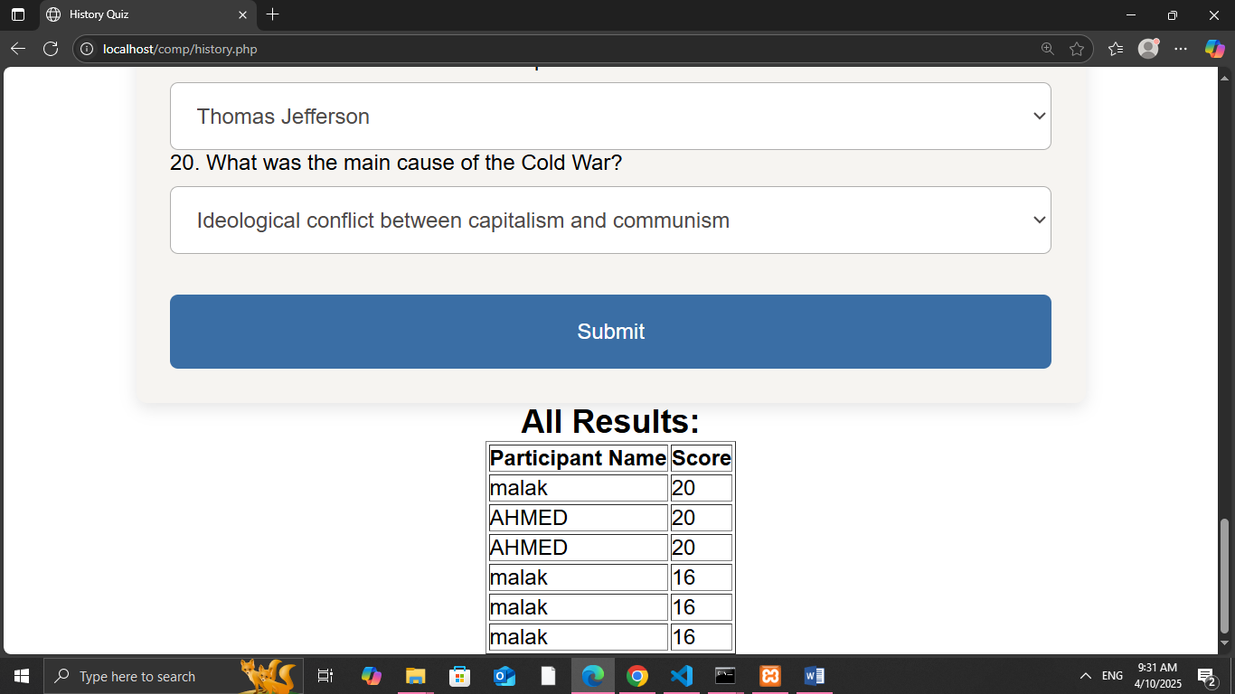

**Test plan**

|  |  |  |  |  |  |  |  |  |  |  |  |
| --- | --- | --- | --- | --- | --- | --- | --- | --- | --- | --- | --- |
| |  |  |  |  |  |  | | --- | --- | --- | --- | --- | --- | |  |  |  |  |  |  |   Test Case ID | What to Test | How to Test | What Should Happen | What Really Happened | Status |
| TC01 | Join as one user | 1. Open site2. Write name3. Click "single" | Goes to quiz and name is saved | As expected | Pass |
| TC02 | Join as a team | 1. Open site2. Add team name3. Click "Join Team" | Team joins and quiz starts | As expected | Pass |
| TC03 | Answer quiz | 1. Answer all2. Click "Submit" | Shows score and dashboard | As expected | Pass |
| TC04 | No name added | 1. Click "single" with no name | Shows error message | As expected | Pass |
| TC05 | Show dashboard | 1. Finish quiz2 | Shows name and score | As expected | Pass |
| TC06 | Save to database | 1. Submit quiz2. Check DB | Name and score are saved | As expected | Pass |
| TC07 | Take quiz again | 1. Refresh or open again | Starts new quiz | As expected | Pass |
| TC08 | Score is correct | 1. Mix right and wrong answers | Shows correct score | As expected | Pass |
| TC19 | Try another quiz | 1. Finish one2. Start another | Other quizzes work fine | As expected | Pass |

Testing Types Covered:

* Functional Testing: Checking if buttons and features work.
* Validation Testing: Making sure required fields are filled.
* Database Testing: Confirming that data is saved correctly.
* UI/UX Testing: Making sure design looks good on all screens.
* Usability Testing: Making sure it’s easy to use.

Tools/Technologies Used:

* Manual testing on browser (Chrome, Firefox, Mobile)
* Database: MySQL / Firebase
* Front-end tools: Developer Tools

**User Feedback (Stakeholder Feedback on Design and Code)**

- "The design is simple and easy to read, but it could be more exciting with color, especially in the quiz sections. Interactive items lagged when clicked."

- "The interface is functional, but it could be more intuitive. The buttons to submit answers are small, and users can miss them on a mobile phone. Having buttons larger for mobile responsiveness would enhance this."

- "The code is generally well-written, but there are performance issues in loading quiz results. It would be better optimized in terms of processing results and displaying them to improve the user experience. Improved error handling for unexpected inputs is also needed."

- "Quiz flow is quite good in general, but question wording in some places was clumsy. Simplifying question language may make it less difficult for students. Moreover, response to answers in real time should be faster."

- "The dashboard itself is very convenient to track progress, but scoring is refreshed after a little delay in real time. Scoring can also be made user-friendlier, and it would be easy to filter results by including a search option."

The website and code have been modified based on these comments.